# Rayice Multi CMS 1.2

# Manual

Understanding the Multi CMS and Building the Successful Pre-Made Websites Using Multi CMS

**Syed Raza Ali – Rayice.Com**

**Team Support by MasterGraphiks.Com**



**RAYICE COMPANY  
Design / Development Company**

**SYED YASSER ARAFAT | SYED JAFFAR HUSSAIN | SYED RAZA ALI**

# List of Abbreviations

**Abbreviation Description**

CMS Content Management System

Multi CMS Multi-Content Management System

PHP Personal Home Page

MySql My Structure Query Language

# CHAPTER 1

# MULTI CMS OVERVIEW

## IN THIS CHAPTER

In this chapter we will discuss about the Multi CMS and the basic administration functionalities. There will be a quick overview around Multi CMS Administrator and then we will discuss the each and every option in next chapter.

* What is the difference between the frontend and the backend of a Multi CMS powered website?
* What are the main administrator menu functions?
* What types of users are there, and how do they relate to the frontend and backend?

# 1 Multi CMS overview

You can access many multi CMS functions and features directly, without having any problem. Below is some admin overview

1

2

3

## 1.1 The Multi CMS

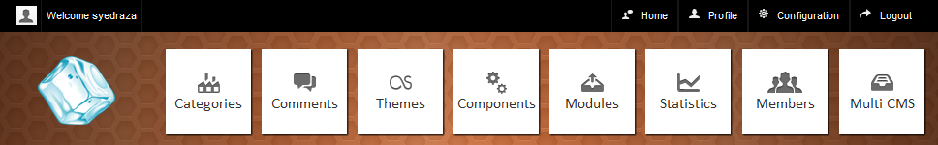

4

5

6

8

7

9

11

10

Figure 1. 1 Navigation Buttons

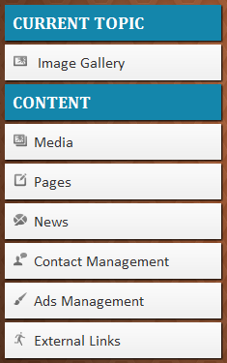

**SIDE BAR MENU**

12

13

15

14

16

17

18

Figure 1. 2 Sidebar Menu

Table 1. 1 List of Administrator Features

|  |  |
| --- | --- |
| Label | Description |
| 1 | Admin Profile |
| 2 | Configuration of Multi CMS |
| 3 | Logout From Administrator Area |
| 4 | Switching B/w Premade Websites |
| 5 | Managing the members |
| 6 | Statistics report of current active site |
| 7 | Modules of the system |
| 8 | Components of the system |
| 9 | Themes management area |
| 10 | active site comments |
| 11 | active site categories |
| 12 | Manage the data of current active site |
| 13 | Uploading Images and use them |
| 14 | Managing Contents of system |
| 15 | News/Blog of active site |
| 16 | Read/Write Messages |
| 17 | Ads Management |
| 18 | External Links |

## 1.2 Admin Menu overview

The following topics provide a quick reference to top-level menus that appears on the Multi CMS administrator Area.

### 1.2.1 MULTI CMS

Following options are available when you click on Multi CMS button on the admin panel.

|  |
| --- |
| List of Available Topic Switch Topic |

*There are premade 10+ websites on the list of available topics. Switch the topic will effect of changing the categories, comments, frontend view and few other options.*

### 1.2.2 MEMBERS

Following options are available when you click on Members button on the admin panel.

|  |
| --- |
| Members Overview  Add New Member  Update Member  Delete Member |

*You can manage the all website’s members in this option.*

### 1.2.3 STATISTICS

Following reports are available when you click on Statistics button on the admin panel.

|  |
| --- |
| Statistics  Top 10 Contents  Pages Overview – By User View  Categories - Recent 10  Members – Recent 15 |

*This will show the report of current active topic; you can view the report of current active topic.*

### 1.2.4 MODULES

Following options are available when you click on Modules button on the admin panel.

|  |
| --- |
| Modules List Active / Disabled Modules |

*You can active or disable the modules of website, few modules only work if their respected component is active as well.*

### 1.2.5 COMPONENTS

Following options are available when you click on Components button on the admin panel.

|  |
| --- |
| Components List Active / Disabled Components |

*There is a list of available components, user can enable or disable the components according to its need.*

### 1.2.6 THEMES

Following options are available when you click on Themes button on the admin panel.

|  |
| --- |
| Themes List  Install Theme  Select Theme  Delete Theme  Widgets |

*Under themes section, you can install the new theme*

### 1.2.7 WIDGETS

Following options are available when you click on widgets button on the admin panel.

|  |
| --- |
| Widgets List Widgets Manage |

### 1.2.8 COMMENTS

Following options are available when you click on comments button on the admin panel.

|  |
| --- |
| Comments Overview  Published / Pending Comments  Delete Comments |

### 1.2.9 CATEGORIES

Following options are available when you click on categories button on the admin panel.

|  |
| --- |
| Categories List  Add New Category Update Category  Delete Category |

## 1.3 Summery

This chapter described the basic overview of Multi CMS. This chapter provided the quick overview of administrator buttons, options and navigations of Multi CMS administrator. For better understanding the Multi CMS and its usability please visit the Chapter 2 of this Multi CMS manual.

# CHAPTER 2

# DOWNLOAD AND INSTALL MULTI CMS

## IN THIS CHAPTER

Multi CMS is New Style CMS provide the best pre-made websites solution. In this chapter we will see the process of downloading the Multi Content Management System, Unpacking it and the choose the best Web Hosting or Local Server to upload The site into server, and using friendly Installation wizard we will complete the installation process.

* How do you install Multi CMS?
* Where can you find the most current Multi CMS files?
* How do you unpack the Multi CMS files on your desktop computer or on a hosting account?
* How do you use the Multi CMS Installation Wizard?

# 2 Download/Install Multi CMS

In this chapter we will see how to create the websites using Multi CMS and what are the requirements for building those websites and installing the Multi CMS.

## 2.1 Requirements for Multi CMS

### 2.1.1 Domain Name

Every website on the web has its own Domain Name, like google, yahoo, msn, rayice. Domain name is alternative of an IP address provided by the web hosting companies. When you purchase any hosting you get ip address, as those ip address cannot be remember easily so we use the Alphabetic/Numeric Names to mask the ip address with those names. This helps to remember the name of website easily. If you are planning to get your Domain name you can go to following websites to register the domain name, Domain name usually cost around $9 to $25 depend on what extension of domain you are selecting.

Popular Domain Providers

* Godaddy.com
* Dynadot.com
* 1and1.com

You can easily purchase domain name from above websites and can find the useful information as well on how to purchase the domain and mask the domain over the webhosting ip using DNS.

### 2.1.2 Web Hosting

Web hosting is a place where we host our website files. Web hosting provides the disk space where upload the websites using File Transfer Protocols Software (Filezilla, Cuteftp). When we purchase web hosting from Web Hosting Providers, they give us the detail of accessing the Control Panel, information of Name Servers, and few other required information’s. Nameserver that is provided by web hosting providers, we use those name servers and put them into Domain Setting. Then the domain name successfully mask to the web hosting ip (DNS Resolving time is up to 48 Hours and sometime get resolve instantly). Once domain name is resolve to web hosting account we purchase. We access the control panel to create the databases and using file manager from control panel or Filezilla we upload the file into server.

Popular Web Hosting Providers are

* Godaddy.com
* Bluehost.com
* Hostgator.com

You can purchase the web hosting from any of above hosting providers as they are cheap and provides linux and windows hosting, as our Multi CMS is build using PHP we prefer Linux web hosting to use. Basic hosting usually cost $3/month to $10/month.

In this chapter we will discuss in detail on how to download and install the Rayice Multi Content Management System.

## 2.2 Preparing the Installation

The process of installing Multi CMS involves several steps:

1. Obtain the latest Multi CMS file package.
2. Create a SQL database.
3. Unpack the package on a server.
4. Installation Wizard

### 2.2.1 Obtaining the Multi CMS file

The home of the Multi CMS project is multimain.rayice.com **[4]**. The Multi CMS site is actually a collection of separate sections and sites for different aspects of the project. Following sections are available

* **multimain.rayice.com** – this section provides the information, files, and other stuff regarding Multi Content Management System. You can download them multi CMS package, Themes, Widgets and other stuff.
* **multimain.rayice.com/forum.php** – Multi CMS forum provide solution to developers or users of Multi CMS software. They can post the questions and answers regarding this software in the forum.
* **multimain.rayice.com/extensions.php** - The Multi CMS Extensions directory provide various extensions that can be used in Multi CMS for different purposes.

When you access the multimain.rayice.com **[4]**, you will see the Download button on the navigation bar. On download page you will see the different Multi CMS versions. Obtain the latest version from their by click on the link.

### 2.2.2 Creating a Mysql Database

Whether set up at home or on a hosted server, Multi CMS needs a MySQL database to serve as a repository for site content.SQL stands for Structured Query Language and has become a shorthand reference to any database structure that responds to requests written in the SQL language. One particular brand of SQL database software is the very popular MySQL, which can be set up on almost any hosted web server, including your home computer. If you are installing Multi CMS locally (on your own computer with WampServer 2.1 or XAMPP). You will need to pre-create a SQL database. When you do, make sure to note the username, password, and database name. The most common way to set up a database is through some sort of button/link in your hosting admin panel; look for MySQL wizard or Mysql Database or something similar.

### 2.2.3 Unpacking the Multi CMS! File

You have to choose either to unpack the Multi CMS! File in Local desktop Computer and install it over their or Unpack the file into Web hosting Server. Follow the wizard you prefer more to complete the unpacking of MultiCMS Files.

### 1 - Unpacking Multi CMS! On Local Desktop Computer

Remember unpacking file and try running site from index.php will not work, as this is not an exe file that run when click on file. To run this file you need to have a server where you put your files and attract with it from client side using localhost. Before purchasing the web hosting you can try running this software into your computer by installing the server. You can find different great software’s to install the localhost server into your personal computer/laptop.

To set up your localhost, you need some software that runs Apache, PHP, and MySQL on your computer. Two popular packages include all these scripts, and both are free:

* **WampServer 2.1** - This package, available at www.wampserver.com/en, is for Windows.**[1]**
* **XAMPP** - This package, available at www.apachefriends.org/en/xampp.html, is for Windows, Mac OS X, and Linux. **[2]**

Let’s quickly run through Multi CMS setup using WampServer 2 for the localhost:

1. Download WampServer 2.1 from www.wampserver.com/en and then install it. At the end of the installation, you will have a folder called c:\wamp\www, which serves as the root folder of a local website. Download XAMPP from <http://www.apachefriends.org/en/xampp.html>, **[2]** the folder will be called c:\xampplite\htdocs.
2. Extract/unpack the Multi CMS zip file you downloaded into a folder inside \www\ or \htdocs\
3. Now Run WampServer **[1]** software and look into Tray with (W) Green Icon.

At this point, all you have done setting up Server and uploaded the Multi CMS files in exact locations on localhost server. Before we go to installation wizard we will see how to unpack files into web hosting account.

### 2 - Unpacking Multi CMS! On a Hosting Account

Either you have hosting or you are going to purchase, if you are going to purchase then hosting minimum requirements for Multi CMS 1.2 are:

* PHP 5.0 or above **[5]**, See [www.php.net](http://www.php.net)
* MySQL 5.0 or above **[6]**, See [www.mysql.com](http://www.mysql.com)

Once you purchase hosting, you will have Web Hosting detail. You can upload the files using File Manager from Control Panel or using FTP software. You will need the host, username and password to access the account through FTP Software.

If you have Cpanel with your hosting company (almost all hosting companies provide it), the first method is usually the fastest and easiest way to do this. You can use this file manager to upload the zip file to the public_html folder (or whatever folder you have as the root folder on your host; www and htdocs are sometimes used). You can then use it to extract the files.

## 2.3 How to install Multi CMS

### 2.3.1 Important Things to Know Before Installing Multi CMS

You must know some important things before starting the Installation Process.

**1 -** First of all you will need to create Database in your Local Server or Web Server  
**2 -** Once you obtain hostname, database, username, password, you will need to edit  
the rayicecms.php file under Connections Folder , Connections/rayicecms.php  
**3 -** Do Not Delete the rayicecms.sql file from Connections Folder, Otherwise Installation Process will not complete  
**4 -** Once Installation is Complete You Can Remove Install.php and rayicecms.sql for security purpose, and later if you need to reinstall the Multi CMS Software, you can re-upload those two files into server for completing the Installation Process from start.  
**5 -** Your Database must be empty before starting new installation process.

### 2.3.2 Getting to Multi CMS! Installation

Before starting the installation process, you will need to make some settings in rayicecms.php file under Connections Folder. Please look into step 1

**Step 1: Database Setting**

First of all you will need to make a database setting. To do this please go to /Connections/rayicecms.php and change the following section according to your database setting

$hostname_rayicecms = "localhost";  
$database_rayicecms = "rayicecms";  
$username_rayicecms = "root";  
$password_rayicecms = "";

**Step 2: Welcome Screen**

Now go to <http://localhost/> for local server, and <http://yourwebsite.com/> for web server. The first page for installation process you will see is Welcome Screen as shown in Figure 2.1.

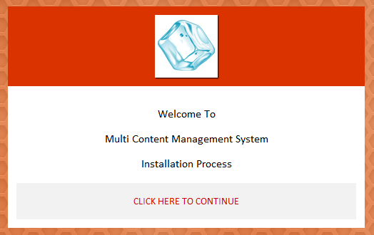

Figure 2. 1 Welcome Sreen (Installation Wizard**)**

Click on Continue Link to go to next Wizard Screen.

**Step 2: Select Topic**

The next screen you will see is the Select Topic. Select the website topic from the drop down list to active the default website. Look into figure 2.2

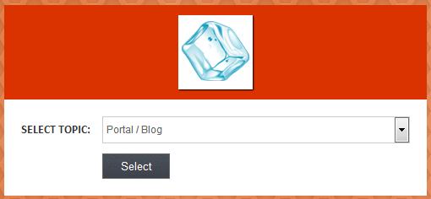

Figure 2. 2 Select Topic Screen Wizard

**Step 3: Confirmation**

Once topic is selected, the confirmation screen will appear as shown in Figure 2.3, you can note down the administrator username and password from there.

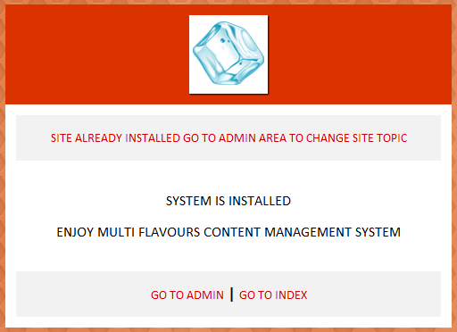

Figure 2. 3 Confirmation Screen

Your System is successfully installed, you can either go to index of website or go to administrator area to control and manage the website.

## 2.4 Summery

Install Multi CMS is a quite confusing for new users however we have provided the best wizard method to make it easy for users to install the system in their local server or web server. We also provided the basic Domain and Hosting Information in this chapter to help you finding better solution to put your website online.

# CHAPTER 3

# BACKEND AND FRONTEND OF MULTI CMS

## IN THIS CHAPTER

In this chapter we will discuss about the MultiCMS and the basic administration functionalities.

* What is the difference between the frontend and the backend of a Multi CMS powered website?
* What are the main administrator menu functions?
* What types of users are there, and how do they relate to the frontend and backend?

# 3 Administration Basics

Multi CMS administrator section is friendly and easy to use however it is better to more understand it before going to develop you website using Multi CMS.

## 3.1 Frontend and Backend

### 3.1.1 What Are the Frontend and Backend of a Multi CMS Powered Website?

After you install Multi CMS, you actually have two sites:

* The public site (commonly called the *frontend*) that people view at www.yoursite.com
* The administration site, also called *admin* for short (commonly called the *backend*), whose URL is www.yoursite.com/administrator

When you browse to the backend, you are greeted by a login prompt, as shown in Figure 3.1. To get any further into the backend, you’ll need an administrative password. I hope you remembered it!

If you log in with an Administrator account, you are presented with the administrative backend of your site. How it looks depends on your administrator level. Look at figure 3.2 for administrator dashboard.

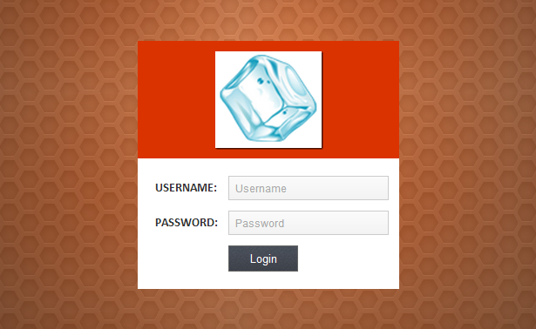

Figure 3. 1 Backend login screen.

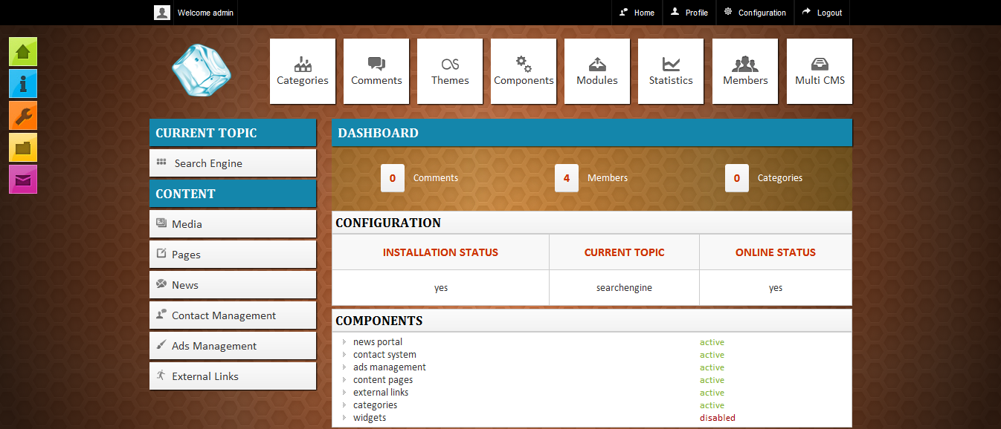

Figure 3. 2 the initial administrative view

In Figure 3.2 the top black bar show the important options related to configuration and settings. On left side there are quick accessible options to important sections; it has buttons showing on below black bar, which give us access to different paths.

### 3.1.2 TOP BLACK BAR

Top black bar shows the main configuration link and profile link. It contains following options that can give access to manage the main settings of website. It consist of

* Profile
* Configuration
* An additional Option (Logout) to destroy the session.

### 3.1.3 NAVIGATION BUTTONS

Immediately below the top black bar contain navigation buttons. It provides access to different website sections where you can control and manage the content of the website, such as Categories, Members, Modules, Components and others. The navigation buttons display other options as well. For example, Figure 3.3 shows the Multi CMS section.

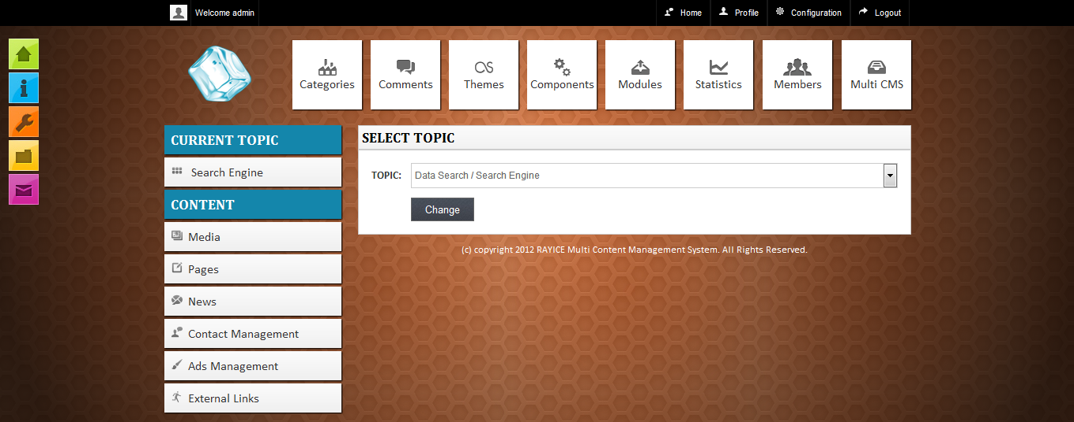

Figure 3. 3 the Multi CMS Screen

While you’re in the Multi CMS screen, you have the select topic dropdown list, which provides feature to switch the website to other topic, for example, we have change Multi CMS to Search Engine / Data Engine, look into Figure 3.3. Once topic is change the Current Topic section on left side will also change according to what topic is select. Look into Figure 3.4 for an example

### 3.1.4 Sidebar Menu

Left side contain the list of other options such as current topic, content section with different further links. The Current topic section provides the active topic that has been selected in Multi CMS screen, look into Figure 3.3

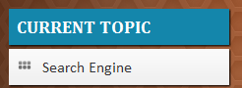

Figure 3. 4 Current Topic Menu

The second section is Content which give access to different other options such as media, pages, news, Contact Management, Ads Management, External Links Management, Etc. Look into Figure 3.5

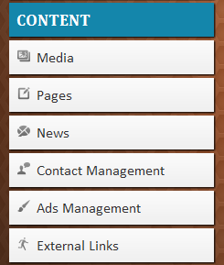.

Figure 3. 5 Content Menu List

## 3.2 Top Black Bar

As just described, the top black bar provides the main configuration and profile links. Main configuration provides the access to manage the global configuration and profile provides the access to manage the administrator / editor profiles. Look into Figure 3.6 and Figure 3.7 for an example of Configuration and Profile Links.

### 3.2.1 Configuration

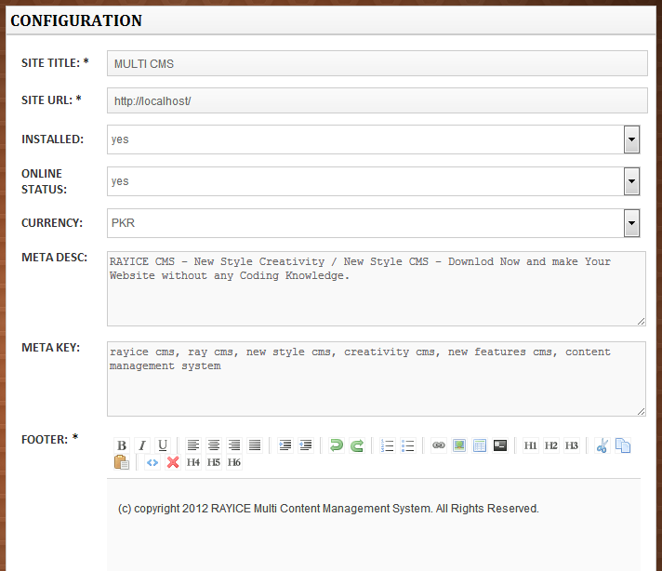

Figure 3. 6 Global Configurations

The Global Configuration screen shows the different fields such as

* **SITE TITLE** – Main site title that appears just before actual title of website, for example MULTI CMS – (Actual Title)
* **SITE URL** – If you are uploading website, you will need to enter the site url here for example (http://multicms.rayice.com/)
* **INSTALLED** – If you want to reinstall the website with different database settings, you can switch the installation option to no and then you will see the installation screen again to provide database settings and other options.
* **ONLINE STATUS** – If you are planning to customize the website then you can switch the Online status to no, your website will go to offline mode
* **CURRENCY** – This is Currency you can change between, this currency used in shopping related and market related websites where prices given.
* **META DESC** – Meta Description basically use for search engines, the description appears in search engine when we search something, it is appear from here.
* **FOOTER** – Here you can enter the footer text appears on each front-end page, such as copyright links.
* **BACKUP** – on left side you will see a link of backup under Current Topic; you can use this option to create your database backup.

### 3.2.2 Profile

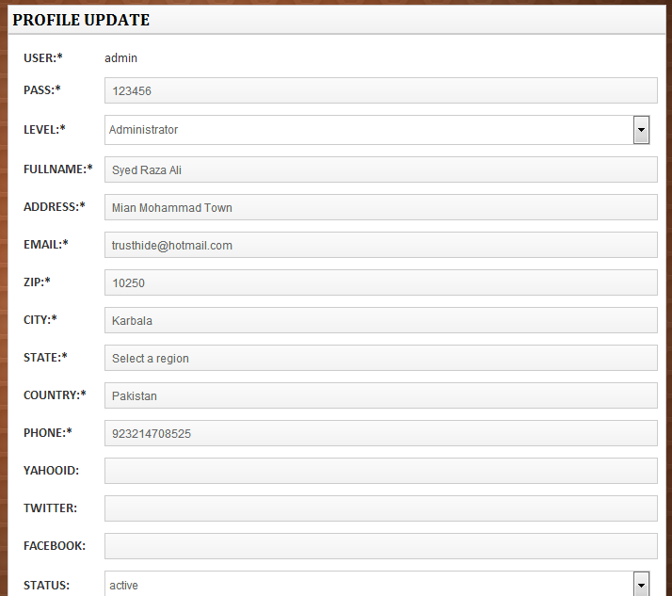

Figure 3. 7 Admin / Editor Profile

The Profile screen shows the options where Administrator or Editor can manage the main profile settings such as

* Username, Password, Full Name, Address, Email, Zip, City, State, Country, Phone, etc

## 3.3 Navigation Buttons

Navigation Buttons contain different sections which provide further administrator functions to manage and control the website and content as seen on Figure 3.8. We will discuss each button step by step.

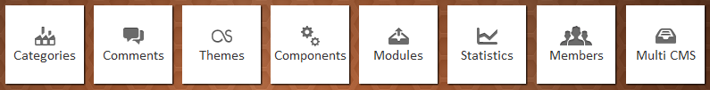

Figure 3. 8 Navigation Buttons

### 3.3.1 Categories

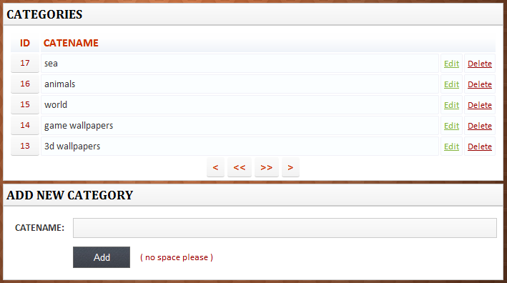

Figure 3. 9 Categories Screen

Under Categories button we can get access to manage the categories of website. There are 10+ premade websites and each websites has different categories, you will see individual categories of each topic you select under Multi CMS button. You can manage the categories of select topic. Look into Figure 3.9 for categories display options. Categories section contain following options

* **Add New Categories** – Adding new category by giving the name of category under CATENAME field and click add, ( *there is an warning of no space between categories to avoid any problem as well no special characters should add to category name, Only simple words are best for avoiding any conflict* )
* **Edit (Category)** – In front of each category you can see the edit text, if you want to update the category by changing its name you can click on edit and follow the next screen to complete the update process.
* **Delete (Category)** – To delete the category you can click on delete button in front of each category, you will get warning before deleting the category.

### 3.3.2 Comments

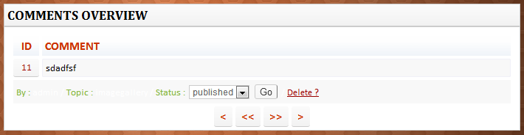

Figure 3. 10 Comments Screen

Comments Button provide the access to Comment screen, where you can manage the comments. Those comments given by users / visitors in frontend websites under each content detail, once they give comments, those comments appear here, an Administrator or Editor the manage the comments as appear in Figure 3.10 Comment Section contain following things

* **Status** – When Comments are given their status remains default Pending, in administrator section
* **Delete** – To Delete comments, click delete button, it will as for confirmation and then will delete the comment.

### 3.3.3 Themes

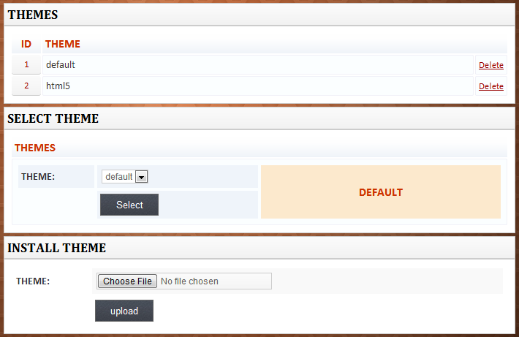

Figure 3. 11 Themes Screen

Themes contain main interface part, in this section we install the themes and select those themes to change the frontend website look. After theme is installed we select the theme from dropdown list. There are some restrictions for themes installation, no every theme supported by Multi CMS. First we need to set the theme according to theme requirements and then install the theme to change the look of website. Look into Figure 3.11 for themes screen. Theme section contain following things

* Themes – This part contain list of themes that has been installed in Multi CMS. There is delete option in front of each theme. To delete them installed theme, click on delete and confirm to delete the theme.
* Select Theme – This section show the dropdown list of installed themes. To active the theme select the theme from dropdown list, and click Select button to install the theme.
* Install Theme – This section provide feature to install new theme into Multi CMS. Installation theme support .zip file.

You can download the theme structure from multimain.rayice.com **[4]** in order to customize the theme according to system requirements.

### 3.3.4 Components

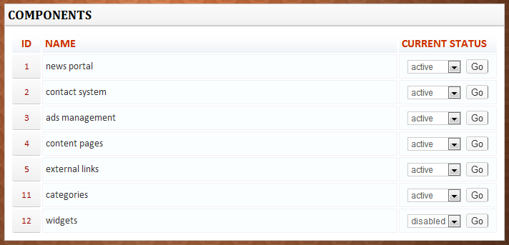

Figure 3. 12 Components Screen

Components screen consist of different built-in components. This section is only accessible by Administrator, Editor cannot access this section. Each component contain dropdown list, from where you can active / disabled any given components. At the time we are supporting Built-in Components, in next released versions there will be an option to install the components. Remember those components can enable or disable the complete system parts that can affect the changes in backend as well in frontend

### 3.3.5 Modules

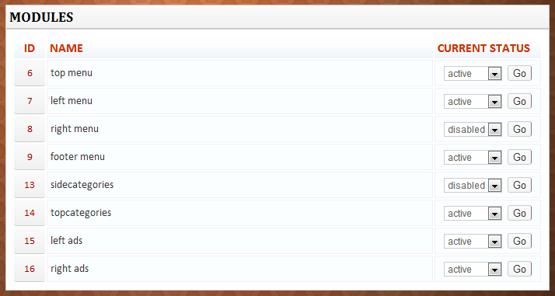

Figure 3. 13 Modules Screen

Modules Screen shows the different available Modules in the list. Modules are the smaller parts of a system, they not affect hardly by enabling or disabling them. Some of modules are attached with the frontend themes and some of the modules are the parts of components. As you can see in Figure 3.13, it’s clearly show the list of built-in modules, which can be active or disabled by select the option from dropdown list.

### 3.3.6 Statistics

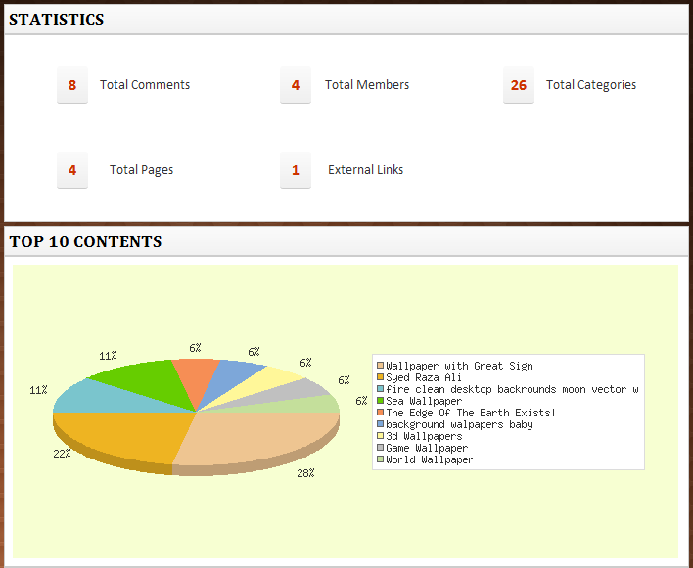

Figure 3. 14 Statistics

Statistics show the reports of most visit content pages of each Multi CMS topic. It also shows the report of contents in graphical representation. Those statistics help the administrator or editor to see which content is in top and what is the recent content added into system. This report can be read and auto generate from the active topic.

### 3.3.7 Members

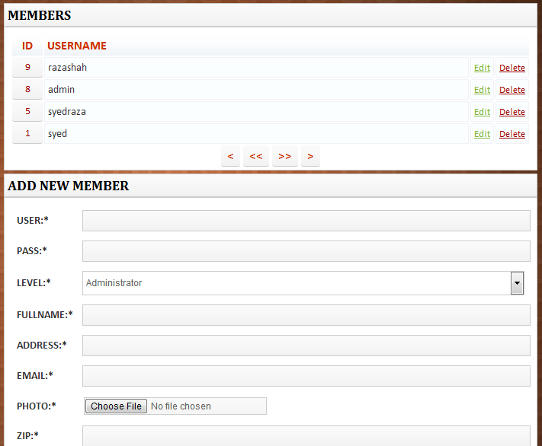

Figure 3. 15 Members Screen

Members section is an important section of website; it provides the administrator managing the registered members of website as well Editors of backend. Administrator control the Level defined for each member. There are 3 types of level in for members.

1. **Administrator** – This level is a super administrator level. This type of member can access the backend section to manage and control everything, members, content, modules, components, themes, Multi CMS, etc.
2. **Editor** – This level is for editors that access the backend section to manage the important section contents. Editor cannot access the main configuration sections like, configuration, members, modules, components and etc. Editor can access only categories, comments, themes, profile, content sections and few others.
3. **Member** – This level is for general members who register into website from frontend and access the member area to manage the content and access the available features from backend. Member cannot access the backend area of the Multi CMS.

### 3.3.8 Multi CMS

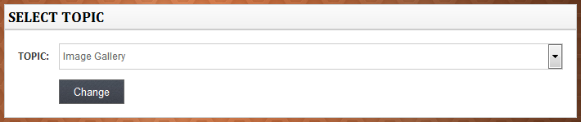

Figure 3. 16 Multi CMS Screen

In This section, Administrator or Editor can switch the website topic to other available topic into website. As soon the topic is changed following options or content will also change.

* **Categories** – Once topic is changed, categories will also change according to selected topic. Some topics does not support categories, so adding or removing categories will not affect anything into frontend website, an example of this type of websites is portfolio / resume website.
* **Current Topic** – Once the topic is switch to other topic in MultiCMS, this section will switch to selected topic name. Example if you select the Image Gallery from list of topics and click on change, you will see the Image Gallery in left side under the Current Topic.
* **Comments** – Comments are given from frontend and they will also change according to the selected topic.
* **Statistics** – This statistics section will also change according to selected topic from Multi CMS. Statistics of each site contain individual, some of the topics does not support the content report such as portfolio / resume as this type of sites mostly contain static contents.
* **Frontend** – As soon the topic is changed from backend under Multi CMS section, the frontend website will totally change according to the selected topic.

## 3.4 Sidebar Menu

Sidebar menu contain two menus, one is Current Topic Menu and second is Content Menu as seen on Figure 3.17

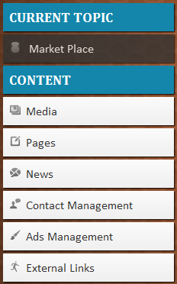

Figure 3. 17 Sidebar Menu

### 3.4.1 Current Topic

Current topic is a section that provides functions to manage the main content of each website active from Multi CMS.

If you look into Figure 3.18 and then Figure 3.19 you will see two different type of topic names under Current Topic Option, this is because when we switch any topic from Multi CMS feature, we get two different topic name according to selected topic from Multi CMS.

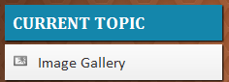

Figure 3. 18 Current Topic (Image Gallery)

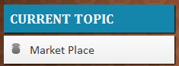

Figure 3. 19 Current Topic (Market Place)

In above screenshots you can clearly see two different types of topics that has been switch according to what topic has been selected by clicking in navigation button Multi CMS. If we click on Market Place button link, we will see the following options showing in Figure 3.20

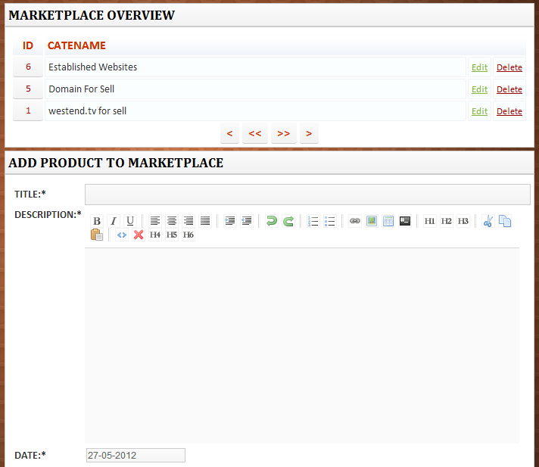

Figure 3. 20 Market Place Screen

In Figure 3.20 we can the marketplace topic content management section. Here we can manage the content of market place, this section only can accessible if the marketplace topic is active from Multi CMS section. This section contain 3 parts

* **Market Place Overview** – Market Place overview section shows the list of available contents in current topic, if other topic is selected this section content will show the other active topic contents.
* **Add Product** – This section provide the feature to add the content to website. Each topic contain different fields to add content to website, Above Figure 3.19 show the screenshot for Market Place topic only, Other topics contain different fields when active.
* **Update Product** – This section appears when click on edit in front of any content in overview section.

Under Content section in Sidebar Menu there are various options like Media, Pages, News, Contact Management, Ads Management, External Links and others. in Figure 3.21 you can see the Content section with menu buttons

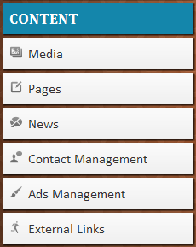

Figure 3. 21 Content Section

### 3.4.2 Media

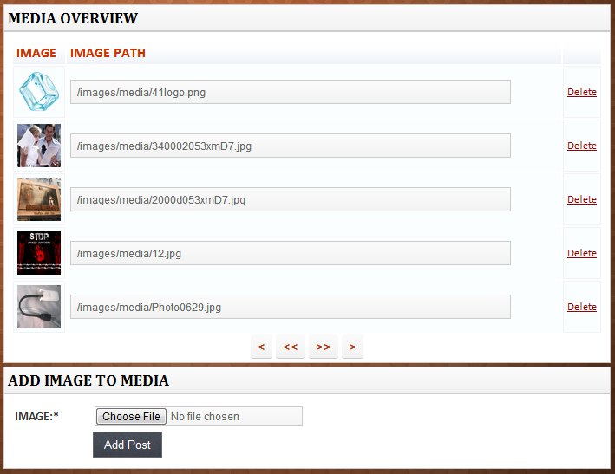

Figure 3. 22 Media Screen

In Figure 3.22 we can clearly see the media content list. We can add any media content from add image section and then using image path we can use this media into content we add in website or backend.

### 3.4.3 Pages

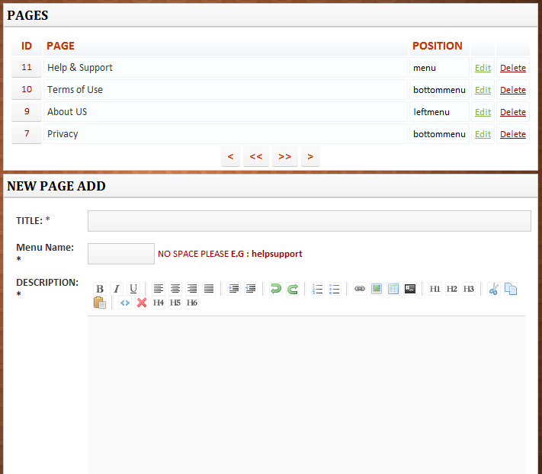

Figure 3. 23 Pages Screen

Figure 3.23 shows the Pages section, this section has link with all 10+ websites where we enter the content and then give the position to adjust the link in given section of frontend. When adding new page we have option to select position of showing link in 3 different locations as seen on Figure 3.24

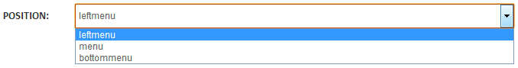

Figure 3. 24 Position Select

Any position we will select the link will appear at that location. If the left menu is selected and left menu is activated from the modules section the pages link will appear on left menu section. If Menu is selected and menu is active from modules then the pages link will appear in menu. If bottom menu is selected and bottommenu/footermenu is activated from the modules then pages link will appear in footers.

### 3.4.4 News

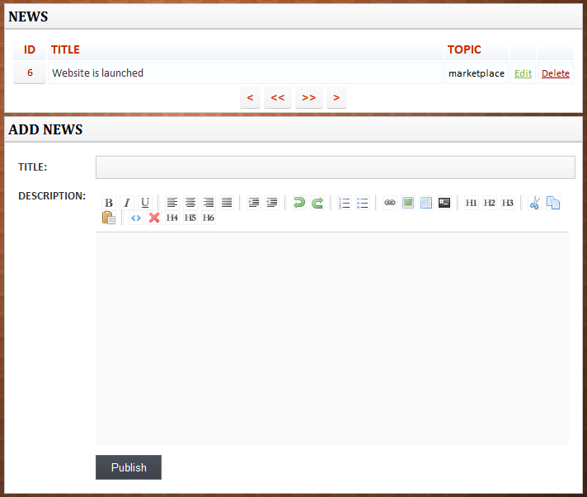

Figure 3. 25 News Screen

Here you can enter the news into website, remember to active the news component to make it appear into frontend. Any news related to anything can be writing here and can be show as blog in frontend. This component attach with all 10+ websites.

### 3.4.5 Contact Management

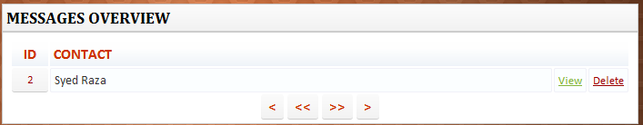

Figure 3. 26 Contact Management Screen

When you click on Contact Management button in content list you will see the screen showing in Figure 3.26. It shows the list of contacts people write from frontend using contact us. When clicked on view link in front of message you see the screen showing in Figure 3.27

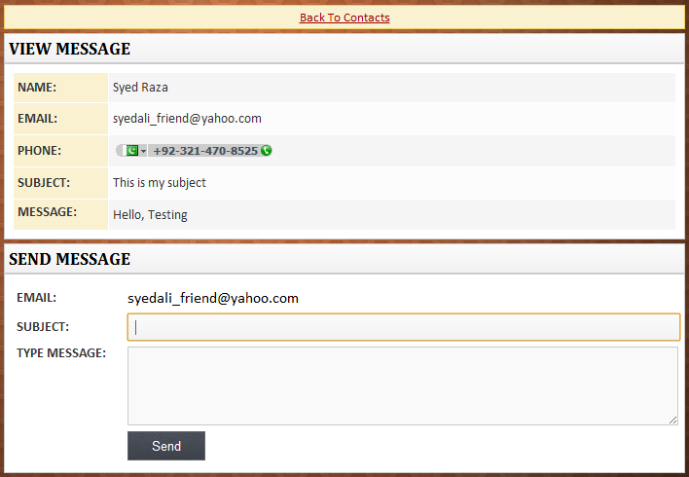

Figure 3. 27 Contact Management (View)

In Figure 3.27 you can see the message as well the other section to send the message, to the person you are viewing the message of.

### 3.4.6 Ads Management

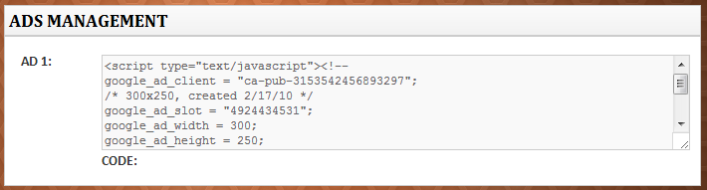

Figure 3. 28 Ads Management Screen

In Figure 3.28 you are seeing an example of ad. You can add any ad from google, yahoo or other ads providing companies and can earn the money or advertise other banners in your website. You can enable the ads showing from the module section.

### 3.4.7 External Links

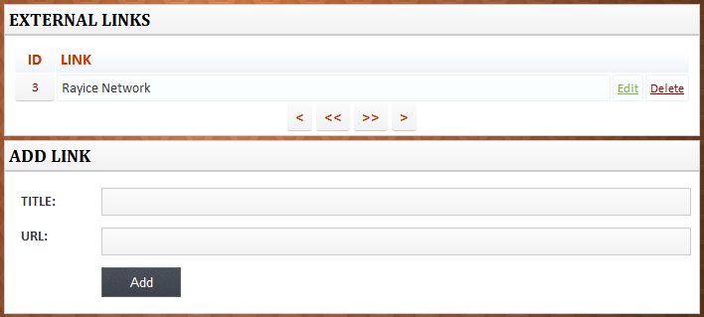

Figure 3. 29 External Links Screen

External Links are attached with all 10+ websites; you can active the external links from components. External Links usual appears in left menu or right menu, but you can adjust to show the links where ever you want by customizing the theme.

## 3.5 Frontend of website

Frontend of website is the site we usual see in when we open the main url example when you open <http://multicms.rayice.com> **[4]** you will see the frontend of website, you can see an example of frontend in Figure 3.30, Figure 3.31, Figure 3.32

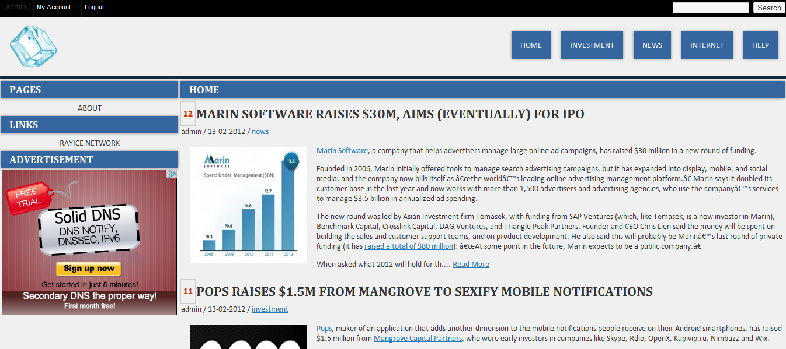

Figure 3. 30 Blog Website

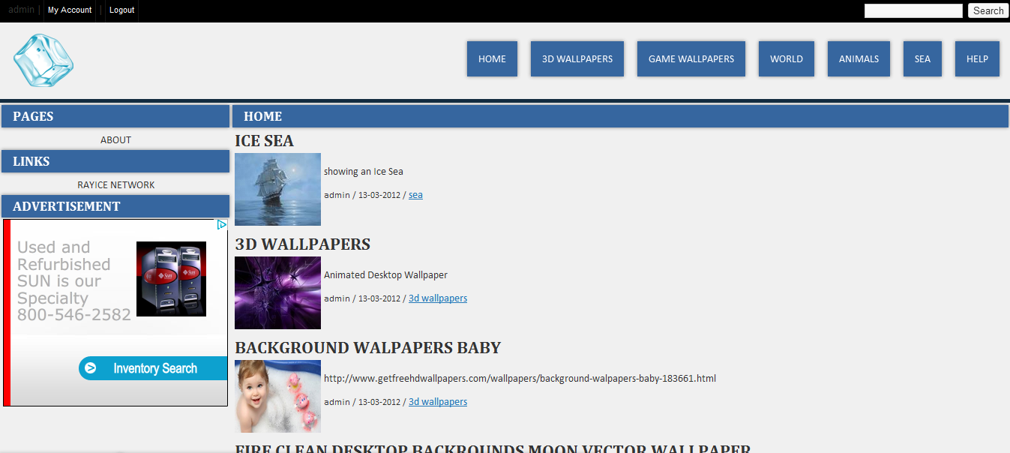

Figure 3. 31 Wallpapers Website

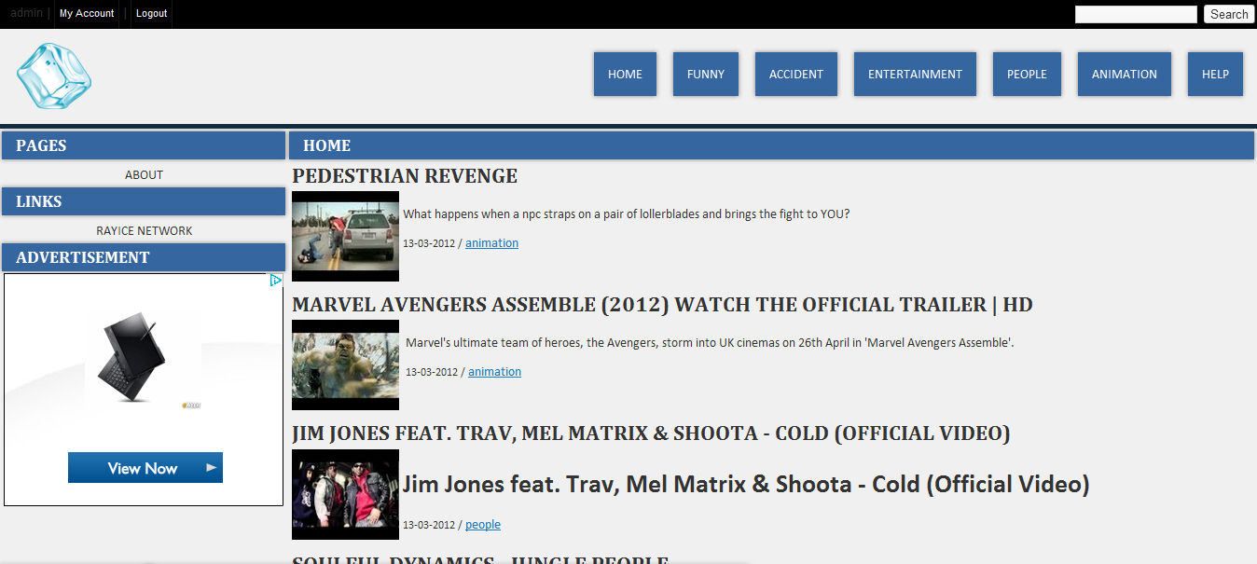

Figure 3. 32 Video Streaming Website

Figure 3.30, Figure 3.31, Figure 3.32 shows the example of frontend websites. Those websites contain different sections that contain

* **Left menu** – Left menu can be enable or disable from modules section of administrator, and can be move to right from administrator modules section. Left menu contain categories, pages, external links and ads menu.
* **Top Menu** – Top Menu contain the navigation buttons, those navigation buttons consist of categories and pages links that auto generate from administrator section.
* **Footer Menu** – Footer menu contain the pages links, news and contact link as well.
* **Search Bar** – Search bar use to search the content of website
* **Main Body** – Main body change in different time according to different options selected.
* **Register** – Members can use this link to create an account into website.
* **Login** – Registered members can use this option to login into website to manage the content.
* **Account** – When user is Registered and login into website, it goes to Account area, where User can access the provided features by system administrator. You can see into Figure 3.33 the account section

### 3.5.1 My Account

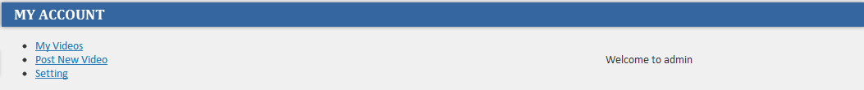

Figure 3. 33 My Account Screen

As we can see in Figure 3.33, my account contain 3 options, it can be change according to what topic is selected. Current active topic website is video streaming and options showing under my account are

* My Videos – Under My Videos member can see the list of posted videos by them. They can manage the content and can post the new content. Members can change the profile setting as well under my account.
* Post New Video – Under this option members can post new video or content to website, this content appear into website when administrator approve the posted content.
* Setting – Under this option member can change his profile setting.

## 3.6 Summery

This chapter described both the frontend and backend of a MultiCMS-powered website and quickly showed how to navigate the administrative backend as well frontend and how to control and manage the content in backend and frontend.

# References

**[3]** Rayice – Web Design/Development Company,”http://rayice.com”, 24/05/2012